BRAILLEBRIDGE
Technical Documentation
Architecture, chord mathematics, firmware, protocol, build and operating guide for the BrailleBridge keyboard.
Document | Technical documentation, version 1.0, October 2026
Author | Samin Yeasar
Email | Sheditzofficial918@gmail.com
Portfolio | solez.vercel.app
GitHub | github.com/Solez-ai/braille.bridge
Official website | braile-bridge.vercel.app
Documentation | braille.mintlify.site
Covers | Firmware v4 (braile.ino with vendored BBKeyboard), Teacher Software, serial and BLE protocol, hardware

1. System overview
BrailleBridge turns six Braille dot keys, a Space key and a Shift key into text. An ESP32 reads the keys, merges near-simultaneous presses into a 6-bit chord, looks the chord up in a dictionary for the active language, and sends the result on three outputs: a Bluetooth LE keyboard (HID), a Bluetooth LE Nordic UART stream, and USB serial. All translation happens on the device, so every host sees finished characters.
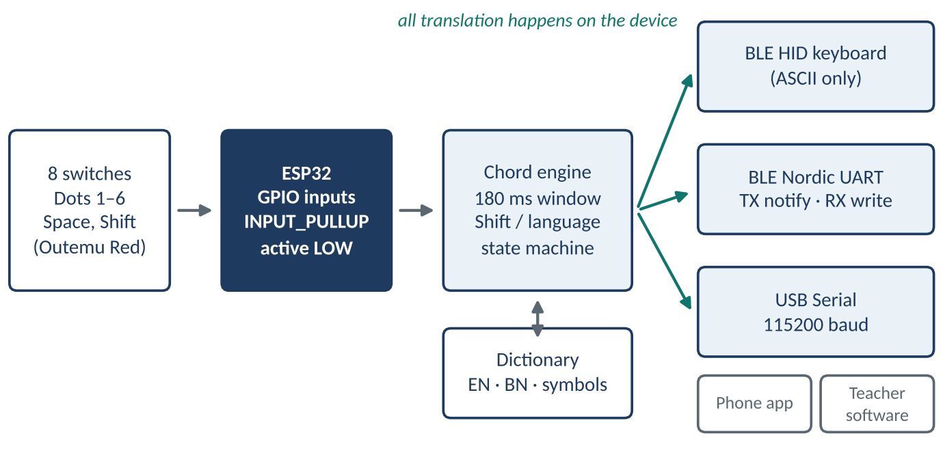
Figure 1. Signal path from switches to hosts. Translation happens once, on the ESP32.

2. Hardware

2.1 Bill of materials
Component | Quantity | Unit note | Cost (USD)
ESP32 Dev Module | 1 |  | 5.00
Outemu Red switch | 8 | 6 dots, Space, Shift | 3.00
Keycaps (3D-printed) | 8 |  | 1.00
LED (3 mm) and resistor | 2 + 2 | language indicators | 0.30
Perfboard | 1 |  | 0.80
PLA filament (enclosure) | 30 g |  | 1.20
M3 screws, wire, solder | — |  | 0.70
Total (prototype parts cost) |  |  | about 12.00
Figures as published in the project repository [8]. They exclude tools, labour and shipping.

2.2 Pin assignment and electrical notes
Function | GPIO | Cell position | Bit | Notes
Dot 1 | 14 | top-left | 0 | weight 1
Dot 2 | 12 | middle-left | 1 | weight 2; boot-strapping pin, see note
Dot 3 | 13 | bottom-left | 2 | weight 4
Dot 4 | 27 | top-right | 3 | weight 8
Dot 5 | 26 | middle-right | 4 | weight 16
Dot 6 | 25 | bottom-right | 5 | weight 32
Space | 33 | dedicated key | — | acts only when no dot is held
Shift | 32 | modifier key | — | hold = modifier, tap = Backspace
Red LED | 18 | English indicator | — | optional indicator
Green LED | 19 | Bangla indicator | — | optional indicator

- Wiring. Each switch connects one pin to a shared ground bus. The firmware sets INPUT_PULLUP, so an unpressed key reads HIGH and a pressed key reads LOW. No external resistors are needed.
- Strapping pin. GPIO12 selects the flash voltage during boot on the classic ESP32. The Dot 2 switch pulls it to ground, which is the safe default level, so the design is compatible. Do not add an external pull-up to this line.
- Debounce. There is no hardware debounce on the dot keys. Software tolerance comes from the 180 ms chord window and the 50 ms lockout after each commit (section 4).
- Enclosure. Print both shells in PLA at 0.2 mm layers. The MX-compatible cutouts let switches snap in without glue or solder, and the shells close with M3 screws.

3. Chord encoding and mathematics

3.1 Bit encoding
A Braille cell has six dots, numbered 1 to 3 down the left column and 4 to 6 down the right. Dot n owns bit n−1 of an integer, so a chord is a sum of powers of two and every chord is a unique value from 1 to 63. Zero means no key is pressed.
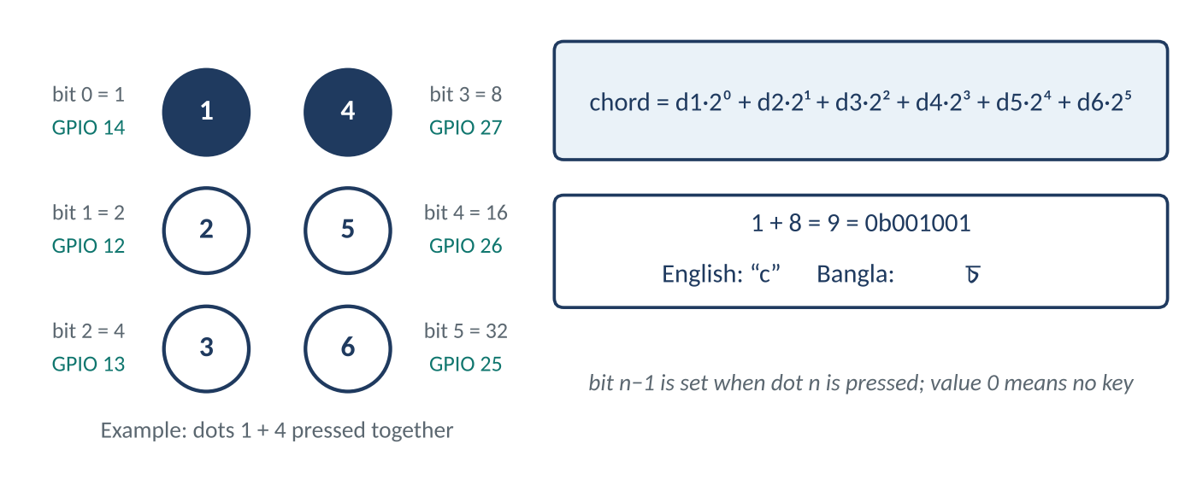
Figure 2. Dot layout, bit weights, GPIO pins and a worked example (dots 1 and 4).
// dots 1 and 4 held together within the chord window
currentChord |= (1 << 0); // dot 1 -> 0b000001
currentChord |= (1 << 3); // dot 4 -> 0b001000
// result 0b001001 = 9 -> lookup -> "c" (English) or Bangla চ

3.2 Counting the code space
Six binary keys give 2⁶ = 64 states, of which 63 are non-empty chords. The number of chords that use exactly k dots is the binomial coefficient C(6, k) = 6, 15, 20, 15, 6, 1 for k = 1 to 6. Because Shift and the language flag each select a different table, the device exposes four layers of up to 63 slots (English, Bangla, Shift-English, Shift-Bangla), or up to 252 addressable outputs from eight keys.
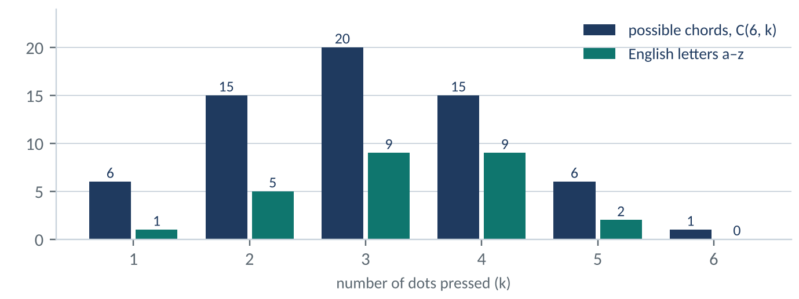
Figure 3. Possible chords by number of dots (navy) against the English letters that use them (teal).

3.3 English table (Grade 1 Braille)
Letter | Dots | Binary | Hex | Letter | Dots | Binary | Hex
a | 1 | 0b000001 | 0x01 | n | 1,3,4,5 | 0b011101 | 0x1D
b | 1,2 | 0b000011 | 0x03 | o | 1,3,5 | 0b010101 | 0x15
c | 1,4 | 0b001001 | 0x09 | p | 1,2,3,4 | 0b001111 | 0x0F
d | 1,4,5 | 0b011001 | 0x19 | q | 1,2,3,4,5 | 0b011111 | 0x1F
e | 1,5 | 0b010001 | 0x11 | r | 1,2,3,5 | 0b010111 | 0x17
f | 1,2,4 | 0b001011 | 0x0B | s | 2,3,4 | 0b001110 | 0x0E
g | 1,2,4,5 | 0b011011 | 0x1B | t | 2,3,4,5 | 0b011110 | 0x1E
h | 1,2,5 | 0b010011 | 0x13 | u | 1,3,6 | 0b100101 | 0x25
i | 2,4 | 0b001010 | 0x0A | v | 1,2,3,6 | 0b100111 | 0x27
j | 2,4,5 | 0b011010 | 0x1A | w | 2,4,5,6 | 0b111010 | 0x3A
k | 1,3 | 0b000101 | 0x05 | x | 1,3,4,6 | 0b101101 | 0x2D
l | 1,2,3 | 0b000111 | 0x07 | y | 1,3,4,5,6 | 0b111101 | 0x3D
m | 1,3,4 | 0b001101 | 0x0D | z | 1,3,5,6 | 0b110101 | 0x35
Grade 1 Braille values.

3.4 Structure of the alphabet
The English letters follow a rule that makes the table easy to verify. Letters a to j use dots from the top four positions (1, 2, 4, 5). The second decade, k to t, adds dot 3 to the first, so chord(k to t) = chord(a to j) OR 0b000100. The third decade, u, v, x, y and z, adds dots 3 and 6 to a to e, so OR 0b100100. The letter w is the exception, equal to j plus dot 6 (0b111010). A script asserted all three rules against the 26-letter table, and they hold.
def chord(dots): return sum(1 << (d - 1) for d in dots)
assert chord([1, 4]) == 0b001001 # c
assert chord([2, 4, 5, 6]) == 0x3A # w = j | dot 6
assert all(K[i] == K[i-10] | 0b000100 for i in range(10, 20)) # k..t

3.5 Confusability: Hamming distance
Two chords that differ by one dot have Hamming distance 1. A single missed or extra finger then turns one letter into another. Among the 26 English letters there are 51 such pairs. The most exposed letters are f, g, k, l, m, n, o, p and q, each with five one-dot neighbours; the letter w has only one (j). This is why the firmware waits for the full chord window before committing, rather than acting on the first key that lands.

3.6 Timing model and throughput bound
Let W be the chord window and L the lockout after each commit. A chord is read correctly when the skew S between the first and last finger is smaller than W, leaving a margin W − S. The firmware ceiling on chord rate is 1 / (W + L), because a held chord commits at W and the next one is ignored for L. The table shows the trade-off; the shipped value is W = 180 ms, L = 50 ms.
Window W (ms) | Cycle W + L (ms) | Chords per second | Characters per minute
120 | 170 | 5.9 | 353
180 (shipped) | 230 | 4.3 | 261
250 | 300 | 3.3 | 200
At 5 characters per word the shipped setting caps the firmware at about 52 words per minute. A chord whose keys all release sooner commits at release, so this is an upper bound set by the device, not by typists.

3.7 Shift layer and Bangla vowel signs
When Shift is held, the firmware checks tables in a fixed order: digits, then maths and punctuation, then English capitals, and in Bangla mode the vowel-sign table and finally the ordinary Bangla cell. Shift plus a to j produces the digits 1 to 9 and 0.
Output | Dots | Binary | Output | Dots | Binary
+ | 2,3,5 | 0b010110 | × | 2,3,6 | 0b100110
- (hyphen) | 3,6 | 0b100100 | = | 2,3,5,6 | 0b110110
÷ | 3,4 | 0b001100 | , | 2 | 0b000010
; | 2,3 | 0b000110 | : | 2,5 | 0b010010
. | 2,5,6 | 0b110010
Symbols are language-independent and need Shift. Plain ASCII symbols also go to the Bluetooth keyboard.
Vowel | Chord dots | Sign (Shift) | Vowel | Chord dots | Sign (Shift)
আ | 3,4,5 | ◌া | এ | 1,5 | ◌ে
ই | 2,4 | ◌ি | ঐ | 3,4 | ◌ৈ
ঈ | 3,5 | ◌ী | ও | 1,3,5 | ◌ো
উ | 1,3,6 | ◌ু | ঔ | 2,4,6 | ◌ৌ
ঊ | 1,2,5,6 | ◌ূ | অ | 1 | none
Bangla dependent vowel signs (kar). The vowel অ has no sign, so Shift plus dot 1 falls through to the ordinary letter.

3.8 Bangla cells in the firmware dictionary
The dictionary holds 52 Bangla entries, following the Bharati Braille family. Several cells are shared with English letters. Five entries carry the dotted circle because they are combining marks: halant (dot 4), anusvara (dots 5, 6), candrabindu (dot 5), and the convenience vowel signs for i and long u.
Cell | Dots | Binary | Cell | Dots | Binary | Cell | Dots | Binary
অ | 1 | 0b000001 | র | 1,2,3,5 | 0b010111 | ঙ | 3,4,6 | 0b101100
ব | 1,2 | 0b000011 | ভ | 4,5 | 0b011000 | য | 1,3,4,6 | 0b101101
ক | 1,3 | 0b000101 | দ | 1,4,5 | 0b011001 | ধ | 2,3,4,6 | 0b101110
ল | 1,2,3 | 0b000111 | জ | 2,4,5 | 0b011010 | ষ | 1,2,3,4,6 | 0b101111
◌্ | 4 | 0b001000 | গ | 1,2,4,5 | 0b011011 | ◌ং | 5,6 | 0b110000
চ | 1,4 | 0b001001 | আ | 3,4,5 | 0b011100 | শ | 1,5,6 | 0b110001
ই | 2,4 | 0b001010 | ন | 1,3,4,5 | 0b011101 | ◌ূ | 2,5,6 | 0b110010
ঐ | 3,4 | 0b001100 | ত | 2,3,4,5 | 0b011110 | ঊ | 1,2,5,6 | 0b110011
ম | 1,3,4 | 0b001101 | ক্ষ | 1,2,3,4,5 | 0b011111 | ঝ | 3,5,6 | 0b110100
স | 2,3,4 | 0b001110 | ছ | 1,6 | 0b100001 | ড় | 1,3,5,6 | 0b110101
প | 1,2,3,4 | 0b001111 | স | 2,6 | 0b100010 | ঠ | 2,3,5,6 | 0b110110
◌ঁ | 5 | 0b010000 | ঘ | 1,2,6 | 0b100011 | থ | 1,4,5,6 | 0b111001
এ | 1,5 | 0b010001 | উ | 1,3,6 | 0b100101 | ণ | 3,4,5,6 | 0b111100
ঞ | 2,5 | 0b010010 | ◌ি | 2,3,6 | 0b100110 | য | 1,3,4,5,6 | 0b111101
হ | 1,2,5 | 0b010011 | ৱ | 1,2,3,6 | 0b100111 | ট | 2,3,4,5,6 | 0b111110
ঈ | 3,5 | 0b010100 | খ | 4,6 | 0b101000 | ঢ | 1,2,3,4,5,6 | 0b111111
ও | 1,3,5 | 0b010101 | ঔ | 2,4,6 | 0b101010
ফ | 2,3,5 | 0b010110 | ড | 1,2,4,6 | 0b101011

4. Firmware architecture

4.1 The chord engine
The main loop polls all eight keys every pass. The first dot down starts a chord and records the time. While the chord is active, each pass ORs the currently pressed dots into the chord value. The chord commits when every dot is released or when 180 ms have passed since the first press, whichever comes first. A special case holds back commit for the exact mask of dots 4, 5 and 6, so a half-second hold can toggle the language instead. After a commit or a toggle the engine waits 50 ms and returns to idle; Shift tap handling runs alongside it (section 4.4).
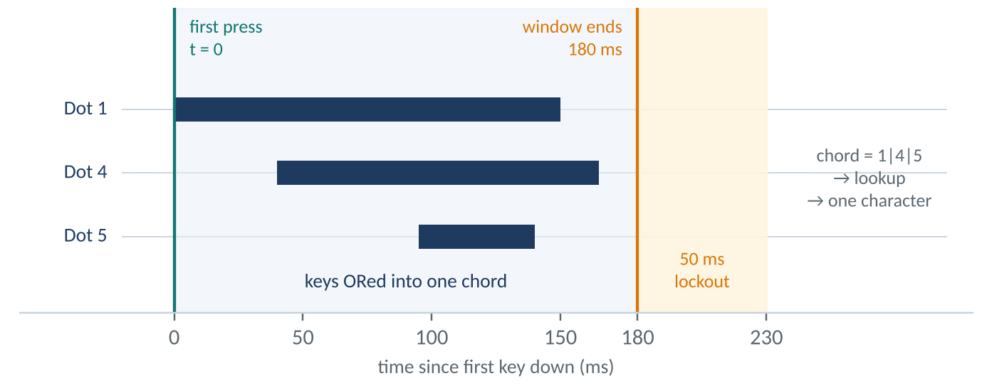
Figure 4. Chord window: keys landing within 180 ms are ORed into one chord, followed by a 50 ms lockout.
if (anyDot) {
if (!chordActive) { chordActive = true; pressStartTime = millis(); currentChord = 0; }
if (d1) currentChord |= (1 << 0); // ... d2..d6 likewise
}
if (chordActive) {
unsigned long elapsed = millis() - pressStartTime;
if (currentChord == 0b111000 && elapsed >= 500 && !allReleased) { toggleLanguage(); return; }
if (allReleased || elapsed > 180) { processChord(currentChord); chordActive = false; delay(50); }
}

4.2 Timing constants
Constant | Value | Purpose
Chord window | 180 ms | Keys within this time after the first press form one chord
Language toggle hold | 500 ms | Dots 4, 5 and 6 held together switch English and Bangla
Post-commit lockout | 50 ms | Blocks bounce and accidental double reads after each character
Space debounce | 200 ms | Space types once, then waits for release
Shift tap, minimum | 25 ms | Shorter presses are treated as bounce
Shift tap, maximum | 1500 ms | Longer holds are ignored so a pocketed device cannot delete text
Backspace cooldown | 100 ms | Stops release bounce from firing twice
HID Backspace pulse | 8 ms | Key down to key up on the Bluetooth keyboard
Serial speed | 115200 baud | USB serial; mirrored over the NUS stream
BLE MTU | 247 bytes | Large enough for any single character or control line

4.3 Dictionary and lookup
Translations live in an array of BrailleEntry records holding a chord, an English string and a Bangla string. A null string means the chord exists in the table but has no meaning in that language, and the press is ignored silently. Lookup is a linear scan; with about 52 entries this takes microseconds on a 240 MHz core, and the table occupies well under 1 KB, so a hash is not needed. Adding a language means adding a column or a second table, not changing control flow.
struct BrailleEntry { uint8_t chord; const char* english; const char* bangla; };
// processChord(), Shift held: digits -> math/punctuation -> EN capital -> BN kar -> BN cell -> ignore

4.4 Shift tap and Backspace
Shift is a modifier whenever dots are involved. A clean tap with no chord sends one Backspace on both outputs: a real HID Backspace over Bluetooth and a SYSTEM:BKSP line on the serial and NUS streams. Four guards prevent misfires: a dot held during the tap vetoes it, a press under 25 ms is ignored as bounce, a hold over 1.5 s is ignored, and a 100 ms cooldown follows each delete.

4.5 The ASCII rule for the keyboard channel
HID key codes cover ASCII only. Pushing multi-byte UTF-8 such as Bangla through the keyboard stack was found to wedge the ESP32, so sendChar() checks every byte and sends to the HID keyboard only when all bytes are below 0x80. Every character, ASCII or not, goes to the serial and NUS streams. Bangla therefore travels to the Teacher Software through these streams.

5. Communication layer

5.1 Channels
Channel | Details | Carries
BLE HID keyboard | Service 0x1812, appearance 0x03C1, name “BrailleBridge”, secure connections with bonding; T-vK BleKeyboard report map | ASCII characters and Backspace
BLE Nordic UART | Service 6E400001-B5A3-F393-E0A9-E50E24DCCA9E; notify characteristic … 0002, write characteristic … 0003; MTU 247 | Full character stream, LANG:*, SYSTEM:BKSP; receives LANG:en and LANG:bn
USB serial | 115200 baud, 8N1 | Identical stream to NUS

5.2 Serial protocol
Characters are sent bare, with no framing. Control lines end with a newline. The host separates them by splitting on newlines and treating anything that matches a control pattern as a command.
Message | Meaning
LANG:en, LANG:bn | Language switched; sent on toggle and on a command from the host
SYSTEM:BKSP | Shift tap; the host deletes the last character
SYSTEM: … | Banner and status lines, never rendered as text
Invalid | Rejected control command from the host
any other text | Translated character data
At power-up the ESP32 ROM prints boot text at 115200 baud. Hosts drop lines beginning ets , rst:0x, boot:0x, configSPIWP, clk_drv:, q_drv:, d_drv:, cs0_drv:, hd_drv:, wp_drv:, mode:DIO, load:0x and entry 0x. After ets the filter stays on until entry 0x or a SYSTEM: line arrives.

5.3 Teacher Software
The Teacher Software is plain HTML, CSS and JavaScript that talks to each device through the Web Serial API in Chrome or Edge. For every student it opens a port at the chosen baud rate, decodes bytes incrementally as UTF-8 so a Bangla character split across reads is never corrupted, and runs a dedicated read loop that feeds each character to that student's feed.
const port = await navigator.serial.requestPort();
await port.open({ baudRate: student.baud });
port.readable.pipeTo(decoder.writable); // TextDecoderStream
for (;;) { const { value, done } = await reader.read(); if (done) break;
for (const ch of value) handleStudentChar(student, ch); }
- Roster and storage. A persistent multi-student roster with per-student port and baud rate is kept in the browser's local storage.
- Views. Live feeds with language detection from the LANG:* lines, an exam mode that shows every student side by side, and an expanded view for one student.
- Records. Every character is timestamped [HH:MM:SS] and exports as a text file. A 500 ms refresh rebuilds each feed from stored data.

6. Build and operating guide

6.1 Build steps
- Print. Print TOP_SHELL.stl and BOTTOM_SHELL.stl in PLA at 0.2 mm layers, plus eight keycaps.
- Wire. Snap eight switches into the cutouts. Solder one leg of each to the shared ground bus and the other to its GPIO pin from section 2.2.
- Flash. Install the Arduino IDE and the ESP32 core, open braile/braile.ino with the vendored BBKeyboard files beside it, select ESP32 Dev Module and upload. No libraries are needed.
- Power on. Supply 5 V over USB. The board advertises over Bluetooth LE as “BrailleBridge”.
- Connect the teacher. Open braille-display/index.html in Chrome or Edge, add a student, connect the USB port at 115200 baud, then type a chord to confirm.

6.2 Operating cheat sheet
Action | Keys | Result
Type a letter | Press its chord within 180 ms | One character
Space | Space key, no dots held | Space
Digit | Hold Shift, press a to j chord | 1 to 9 and 0
Capital letter | Hold Shift, press a letter chord (k to z at present) | Upper case
Symbol | Hold Shift, press a symbol chord | Punctuation or maths
Bangla vowel sign | In Bangla mode, hold Shift, press a vowel chord | Dependent sign (kar)
Backspace | Tap Shift alone | Deletes one character
Switch language | Hold dots 4, 5 and 6 for 500 ms | LANG:en or LANG:bn

6.3 Troubleshooting
Symptom | Likely cause | Action
Teacher Software shows no device | Not powered, out of range, or not connected | Check power, move closer, reconnect
Teacher Software sees no port | Unsupported browser, or port busy | Use Chrome or Edge; close other serial tools; set 115200
Garbage at power-up | ESP32 ROM boot text | Handled by the boot filter; reload if it persists
A chord does nothing | No entry in the active language | Check the tables; unknown chords are ignored
A letter repeats | Keys held after commit | Release all keys fully between chords

7. Verification and future work

7.1 What has been verified
The firmware has been through four on-hardware revisions, documented in the repository: a hand-built GATT layer was replaced, and v4 returned to the proven T-vK BleKeyboard code with the Nordic UART Service added. The chord tables in this document were checked against the source, and the 26-letter structure rules in section 3.4 were verified programmatically.

7.2 Iterations in progress
The following work is under way to make typing faster, more forgiving and more comfortable:
- Autocorrect. Correction of mistyped chords and words, informed by the Hamming-distance analysis in section 3.5.
- Better typing on the keys. Refining chord recognition so fast, natural typing is read accurately.
- Faster response timings. Tuning the chord window and post-commit lockout in section 4.2 against real typing speeds.
- New input methods. Exploring clever ways to enter common letters, words and actions faster than a plain chord.
- Ergonomic layout. Redesigning the key layout and enclosure for comfort during long sessions.
- Roadmap items. Mathematical Braille, battery power with USB-C charging, audio and vibration feedback, secure examination mode, document export and multi-school deployment [8].
Sources: the BrailleBridge repository, documentation and website [8]: github.com/Solez-ai/braille.bridge, braille.mintlify.site, braile-bridge.vercel.app.

